S4 Appendix. Follow-Up Post Card
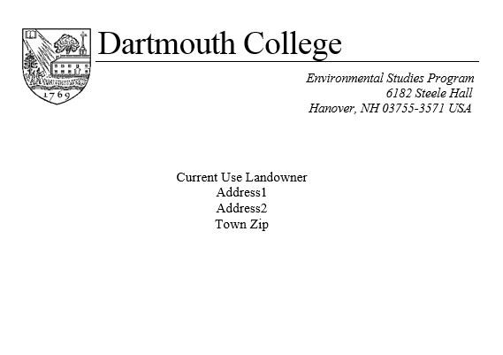

January 26, 2017
Last week, an important survey was mailed to your household or business because you were randomly selected to participate in a study about forest landowners in Vermont’s Current Use program.
If someone at this address has already completed and returned the survey, please accept our most sincere thanks. If not, please have an adult from your household or, if applicable, a representative or trustee do so as soon as possible. By completing this survey, you may help improve opportunities for forest owners in Vermont’s Current Use program. We are very grateful for your help with this study.
If you never received the survey or it was misplaced, please call us at 518-222-3743 or email us at Alisa.E.White.17@dartmouth.edu and we will mail you one promptly.
Sincerely,

Alisa E. White
Dartmouth College Class of 2017
Environmental Studies Program

